Task: Bash Scripting

Objective
Write a Bash script to read the contents of a protected file (secret.txt) using read_secret.sh and print the output on screen.

Question & Answer
Q: Write a script to read the contents of secret.txt. What is inside secret.txt?
Answer: flag{you_wrote_an_script}

Bash Script Written (read_secret.sh)
#!/bin/bash
# Read secret.txt into a variable
secret=$(cat secret.txt)

# Print the value of the variable
echo "$secret"

Commands Used
Command | Description
nano read_secret.sh | Open script in nano editor to write the bash script
cat read_secret.sh | Print script content to verify it
chmod +x read_secret.sh | Attempt to give execute permission (not permitted by machine)
./run_secret secret.txt | Execute via run_secret → flag{you_wrote_an_script}

Screenshot 1 — Full Terminal Output
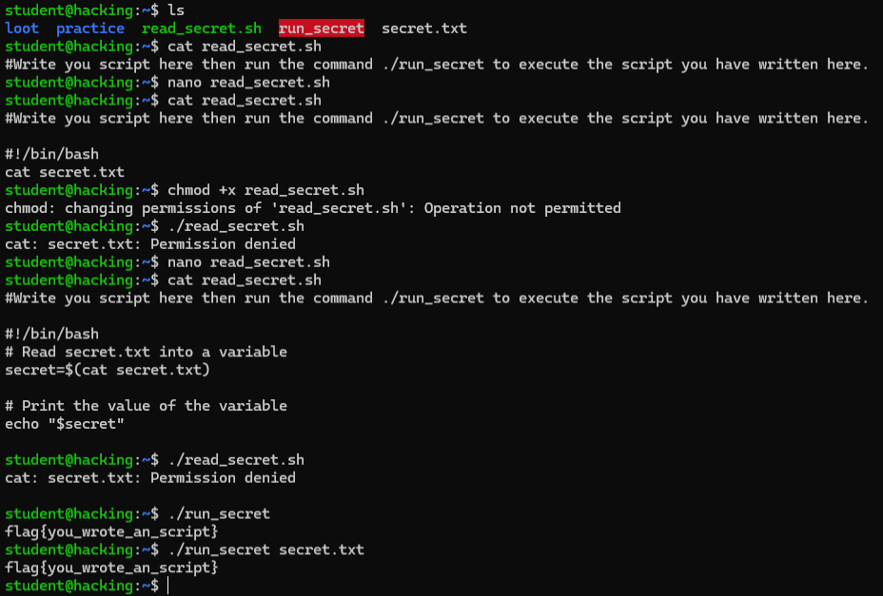
Figure 1: Full workflow — writing script with nano, running via run_secret, capturing the flag

Screenshot 2 — Flag Output
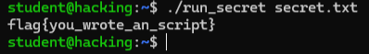
Figure 2: ./run_secret secret.txt → flag{you_wrote_an_script}

Screenshot 3 — Script Content
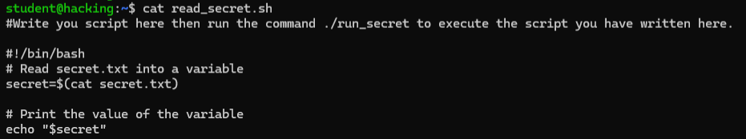
Figure 3: cat read_secret.sh — bash script content printed to terminal

Environment Details
- Platform: TryHackMe (tutedude-cybersec room)
- OS: Ubuntu 24.04.4 LTS
- Target IP: 192.168.155.129
- Username: student
- Access Method: SSH via PowerShell

